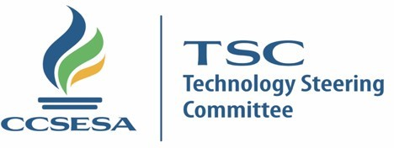 CHAIR REPORT

6/21/2021 | Ryan Choate Alameda County Office of Education

GOALS
- Digital Divide, proactively identify technology and funding for students access to technology and connectivity.
- Disaster Recovery Build the capacity & provide best practices for LEA’s to recover from natural / man-made disasters & Cyber threats.
- Cybersecurity provide best practices security guidance to LEA’s.
- Legislative Advocacy guiding principles for broadband.

Previous Meeting Highlights [4/23/2021]
- CDE updates and support Calpads & distance learning discussion
- K12-HSN update internet access and E-Rate
- CSIS update Cyber security discussion
- CITE update , Digital divide tool kit overview
- CalSNAP presentation around safe K12 content
- ESSER funds program overview
Ongoing Initiatives & Plans
Should be an update for superintendents based on prior work and discussions.
- Cybersecurity Subcommittee meeting 4/22/2021 Improve CyberSecurity practices and develop policies in COEs, districts, and schools to promote a safe/secure learning and work environment.
- schools to promote a safe/secure learning and work environment.
- Disaster Recovery Subcommittee Is creating tools for LEA’s to prepare for disasters related to technology.
- Legislative Advocacy
- Digital Divide, proactively identify technology and funding for students access to technology and connectivity.

Concerns & Considerations
Things the superintendents need to be apprised of in relation to steering committee interactions, work, or emerging issues.
- Guiding principles for broadband legislation
- E-Rate Funding for Distance Learning.
- Internet Connectivity for Distance Learning.
- Exploring the creation of a data subcommittee.
- Cyber Security

Action Items
Can include things that need input and superintendents' feedback & partnerships. Please err on the side of adding too much information.
- TSC Legislative Advocacy Subcommittee Chair Nominations. TSC is building a committee focusing on guiding principles for broadband legislation related to technology initiatives and advocacy. TSC members are meeting this month and will be communicating with the CCSESA staff, superintendents and legislative committee to ensure our guidance is in alignment with CCSESA.
- Digital Divide, TSC is working with partners to identify areas of need for student and staff access to reliable Internet for distance learning.
- Cyber Security Committee is creating tools/Training for LEA’s to reduce the risk of Ransomware & Cyber Threats.
Upcoming Meeting Dates
June 24-25, 2021
October 21-22, 2021

TECHNOLOGY STEERING COMMITTEE

