Dr. Stacey Adler, Mono County Superintendent of Schools, Biography

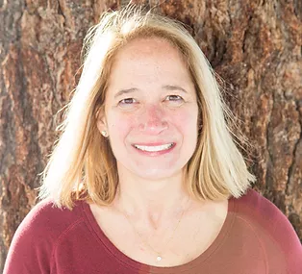
Dr. Stacey Adler has been serving as the Mono County Superintendent of Schools since 2010. In addition to her position as the County Superintendent, she also serves as the Mono County Library Executive Director and has held this position since 2010. The Mono County Office of Education (MCOE) is the only county office of education in California that oversees a County Library System. Prior to becoming the County Superintendent, Dr. Adler worked as an Assistant Superintendent of Instruction for four years for MCOE, as the Mammoth Elementary School Principal for six years, District GATE Coordinator in the Solana Beach School District for two years and a K-8 Classroom teacher for over ten years. She received her B.A. in Public Administration from Miami University in Ohio, her M.A. in Teaching from National College of Education in Illinois and her Ph.D. in Educational Leadership from Capella University in Minnesota.

Dr. Adler currently serves on the Fiscal Crisis Management Assistance Team (FCMAT) Board. She has chaired the Small County Caucus for the California County Superintendents Education Services Association (CCSESA) since 2012 and passionately advocates for rural small counties on both a state and regional level. Dr. Adler has served on the CCSESA Board of Directors and as the CCSESA President in 2018. Locally, she has served as a First 5 Commissioner since 2010, is currently the Chair of the Mono County Childrens’ System of Care Interagency Agency Leadership Team. In 2021, Stacey was selected by the State Board of Education to serve as a commissioner on the Advisory Commission for Special Education.

Superintendent Adler’s favorite days are when she is at school sites visiting classrooms. Her understanding of the importance of teachers’ and school’s role in a student’s life fuels her desire to make a difference in her role as County Superintendent. Over her three terms, she has brought art programs, on site school counseling, Social and Emotional Learning opportunities, an early literacy program and a summer Arts Institute for teachers to attend to learn about integrating arts in the classroom. Since 2019, Dr. Adler has co-hosted the Oxygen Starved Podcast with the Mono County Library Director, Christopher Platt, with the intention to promote the importance of libraries, reading and the natural history and beauty of the Eastern Sierra.

Dr. Adler was born and raised outside of Chicago, but has spent the majority of her life in California, living for nearly the last twenty years in the Eastern Sierra. She and her husband, Joe, have three children, one dog and enjoy hiking, fishing and skiing.

