\***Please make sure that you use Google Chrome, Microsoft Edge, Firefox, or Safari as your browser when utilizing SalesForce**\*. Internet Explorer will cause issues and may prevent you from setting your password.

**STEP 1)** Please access the portal at the following link: [https://caloes.force.com](https://gcc01.safelinks.protection.outlook.com/?url=https%3A%2F%2Fcaloes.force.com%2F&data=04%7C01%7CRyan.Becze%40CalOES.ca.gov%7C6de7e25187b0462cc84b08d8875e7918%7Cebf268ae303647149f69c9fd0e9dc6b9%7C1%7C0%7C637408187140769400%7CUnknown%7CTWFpbGZsb3d8eyJWIjoiMC4wLjAwMDAiLCJQIjoiV2luMzIiLCJBTiI6Ik1haWwiLCJXVCI6Mn0%3D%7C1000&sdata=LORTS5%2BJ9VxD8aUOZnFZxFO8EU1cRyeN7PGxqauscOk%3D&reserved=0)

**STEP 2)** Click **Sign Up**

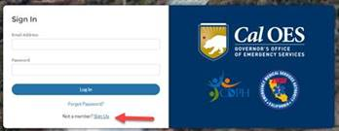

**STEP 3)**

Enter your information. For **Entity Type** select **State Agency**.

For **State Agency**, select California Department of Education (CDE). Once complete, Click **Sign Up** (blue button).

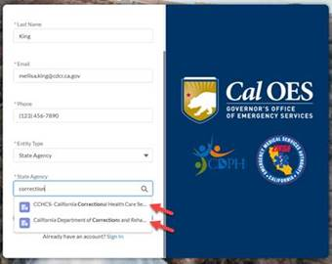

**STEP 4)** Check your Email (please check your junk folder as well). You will need to verify your email by clicking the link sent to you and set your own password.

**STEP 5)** Once logged in, hover over the Public Health Ordering System Icon and select Register for App. This will send a notification to Cal OES to approve your account. Once approved by Cal OES, you will have the ability to access the app and submit resource requests.

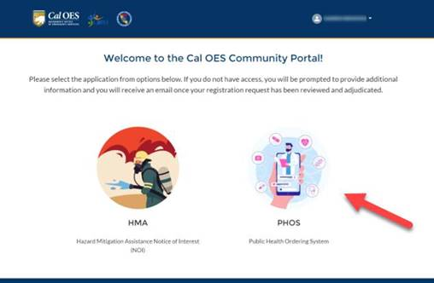

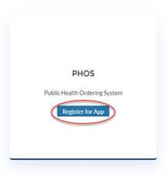

**STEP 6)** Account approval: Your account has been approved and please watch the attached video to assist you with placing your first request.

**Step 7)** Log in and Create Order. Click the YouTube link: <https://youtu.be/nRYj-81GSXQ> in order to see the instructions on how to create an order.

For Technical Assistance please email [SOCMHCCOPS@soc.caloes.ca.gov](mailto:SOCMHCCOPS@soc.caloes.ca.gov) and a team member will reach out to you.