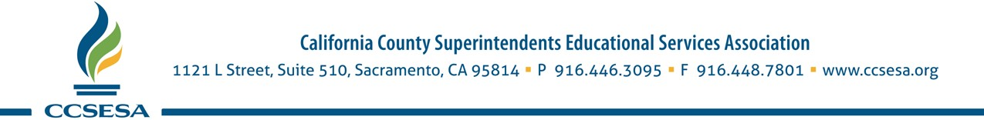
May 10, 2021
The Honorable Toni Atkins
Re: James McQuillen
Appointment to State Board of Education
Senate Rules Hearing May 19, 2021
Senate President pro Tempore
Chair, Senate Rules Committee
State Capitol Room 400
Sacramento, CA 95814

Dear Senator Atkins:

The California County Superintendents Educational Services Association (CCSESA) is pleased to submit this letter of support for the appointment of James McQuillen to the State Board of Education. CCSESA advocates on behalf of K-12 and early childhood education at state and federal levels, and in partnership with state agencies. Our membership consists of the 58 county superintendents statewide, who represent over 1,000 school districts and the 6 million students that attend our public schools.

Mr. McQuillen is a Yurok tribal citizen from the village of Turip along the lower Klamath River in far Northern California and has been an advocate in education for more than 30 years. He has served as the Director of the Yurok Tribe’s Education Department since 2004 where he oversees more than 75 employees working to improve scholastic outcomes for students of every age, ranging from toddlers to college students. The Department is comprised of three Head Starts, the nationally recognized Yurok Language Program, a Higher Education Program and several other services that support the advancement of tribal youth. Additionally, McQuillen headed up the team that paved the way for the Yurok language to be taught in three separate school districts. He is a lifelong practitioner of the Tribe’s rich culture and he brings an important lens to his decision-making on the State Board of Education issues, particularly as it impacts our population of tribal students throughout the state.
Mr. McQuillen currently serves as the State Board Member Liaison to the California Association of Student Councils (Student Advisory Board on Education) and the California Workforce Pathways Joint Advisory Committee, working with committees that directly impact programs and opportunities for students.

For the above reasons, CCSESA strongly supports the appointment of Mr. James McQuillen to the State Board of Education.
Sincerely,

L.K. Monroe
Alameda County Superintendent of Schools
President, CCSESA

