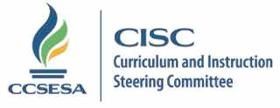

2016-17 CISC Subcommittee Members

Accountability | Region | County | Email
Judy Flores | 2 | Shasta | jflores@shastacoe.org | Lead
Olivia Fuentes | 11 | Los Angeles | Fuentes_olivia@lacoe.edu | Co-lead
Jennie Snyder | 1 | Sonoma | jsnyder@scoe.org
Dorothy Griffin | 3 | Sutter | dorothyg@sutter.k12.ca.us
Gary Waddell | 4 | San Mateo | gwaddell@smcoe.org
Mary Anne James | 5 | Santa Cruz | majames@santacruz.k12.ca.us
Jane Steinkamp | 6 | San Joaquin | jsteinkamp@sjcoe.net
Charlene Stringham  John Magneson | 7 | Tulare  Merced | charlenes@ers.tcoe.org  jmagneson@mcoe.org
Ellen Barger | 8 | Santa Barbara | ebarger@sbceo.org
Jean Madden-Cazares | 9 | San Diego | jmadden@sdcoe.net
Cynthia Glover-Woods | 10 | Riverside | cwoods@rcoe.us
Updated 1/6/17 cd

