COUNTIES ON THE MOVE ARTS PUBLICATION
SUBMISSION TEMPLATE – DUE January 15, 2020
Region:
County:
Primary Contact for this project:
Phone:
Email:
Contribution List
- Choose elements from the list below that best reflect the work in your county.
- You may submit any number of items on the list below.
- Enter the information in the boxes below.
  - A short quote (1-3 sentences) from the County Superintendent on the importance of arts education or the impact of an arts education experience. This item is not optional. To be uniform throughout the publication, we would like to include a quotation from each County Superintendent.

Menu of items that you may include in your submission:
  - A paragraph that explains the approach the county office takes in providing assistance to school districts and schools in the area of arts education.

  - A paragraph or two that provides details on one or more arts education program(s) or support systems provided by the county office or partnership program(s) with organizations such as arts councils, museums or colleges/universities.

  - A paragraph or two that details arts education instructional programs, projects, collaborations, or other best practices in one or two school districts or schools in the county.

  - 3-7 high resolution electronic photos that showcase educators and/or students doing the following: a) engaged in arts instruction or arts professional learning; b) performing in the arts’ c) creating or evidence of student artwork; d) community engagement (or exhibits/performances) in the arts or art-making. We welcome pictures that include you and some students, if you have them available. Be sure that you have signed releases for using the photos in this publication. Files should be high resolution .jpg files.

Due Date:
Send submissions by January 15, 2020 to Jessie Mapes at jmapes@ccsesa.org
Contact/Questions:
Jessie Mapes, CCSESA Arts Program Assistant
Office (916) 446-3095 or Direct (916) 400-0455

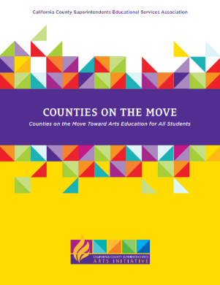
To view the 2016 Counties on the Move publication, go to:
https://ccsesaarts.org/wp-content/uploads/2016/04/Counties-on-the-Move-2016.pdf

