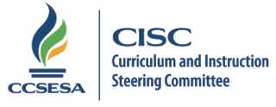
2015 CISC Subcommittee Members

School Readiness | Region | County | Email
Natalie Woods Andrews | 3 | Sacramento | nwoodsandrews@scoe.net | Co-lead
Nancy Herota | 3 | Sacramento | nherota@scoe.net | Co-lead
Cindi Kaup | 1 | Humboldt | khaup@humboldt.k12.ca.us
Kathy Berry | 2 | Shasta | kberry@shastacoe.org
Pamela Comfort | 4 | Contra Costa | pcomfort@cccoe.k12.ca.us
Cathy Cranson | 5 | Monterey | ccranson@monterey.k12.ca.us
Kim Ott | 6 | San Joaquin | kott@sjcoe.net
Michele Copher | 7 | Fresno | mcopher@fcoe.org
Julie Parsons | 8 | Kern | juparsons@kern.org
Eddie Hernandez | 9 | Imperial | ehernandez@icoe.org
JoAnne Lauer | 10 | Riverside | jlauer@rcoe.us
Judy Sanchez | 11 | Los Angeles | Sanchez_Judy@lacoe.edu

9.10.15/lb

