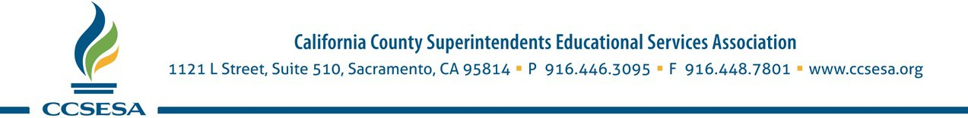

October 28, 2021

Linda Darling-Hammond, President, and Members of the State Board of Education
State Board of Education
1430 N Street
Sacramento, CA 95814
Via email: SBE@cde.ca.gov

Re: Item #18: New Targets for State Performance Plan Indicators in the Annual Performance Report for Part B of the Individuals with Disabilities Education Act of 2004, covering program years 2020–21 through 2025–26.

Dear President Darling-Hammond and Members of the State Board of Education:

We respectfully submit this letter on behalf of the Student Programs and Services Steering Committee (SPSSC) and Special Education Administrators of County Offices (SEACO) of the California County Superintendents Educational Services Association (CCSESA).

SPSSC and SEACO appreciate the ongoing efforts to consult and partner with educators, parents, families, school and district administrators, policy advisors, school psychologists, Family Empowerment Centers, early education, advocacy groups, and state advisory board members. CDE has provided ample opportunities for stakeholders to help inform the development of a new set of rigorous state targets for the next six-year State performance Plan cycle.

We value the opportunities provided to give input on the new targets for the performance
indicators and the efforts of the CDE to align accountability and continuous improvement efforts
for students with disabilities across the requirements of IDEA and LCFF as much as possible.

The CDE’s goal to align LCFF and IDEA continuous improvement activities to improve outcomes for students with disabilities with the expertise of the Statewide System of Support (SSOS) will be
a critical component to the integration of special education activities and technical assistance
for LEAs to improve outcomes for students with disabilities. The increasingly integrated approach
to support LEAs in continuous improvement efforts targeting students with disabilities within a single coherent system is both practical and necessary.

The continued expansion of Multi-Tiered Systems of Support in California is critical to
setting a foundation for LEAs to improve outcomes for students with disabilities, as is the CDE’s plan to
work together with all of the Statewide System of Support partners to explore and develop more resources and supports for LEAs and teachers to address the more rigorous targets for the Least Restrictive Environment.

Thank you for your leadership and support for California’s public schools and students. We appreciate the opportunity to provide feedback and look forward to a continued partnership.

Sincerely,

Susan Connolly
Assistant Superintendent Student Services, Placer County Office of Education
Chair, SPSSC

