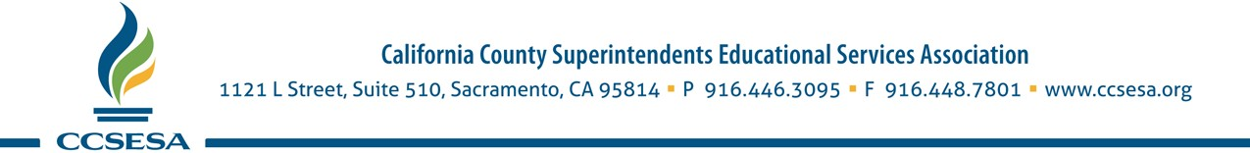
May 10, 2021
The Honorable Toni Atkins
Re: Haydee Rodriguez
Appointment to State Board of Education
Senate Rules Hearing May 19, 2021
Senate President pro Tempore
Chair, Senate Rules Committee
State Capitol Room 400
Sacramento, CA 95814

Dear Senator Atkins:

The California County Superintendents Educational Services Association (CCSESA) is pleased to submit this letter of support for the appointment of Haydee Rodriguez to the State Board of Education. CCSESA advocates on behalf of K-12 and early childhood education at state and federal levels, and in partnership with state agencies. Our membership consists of the 58 county superintendents statewide, who represent over 1,000 school districts and the 6 million students that attend our public schools.

Where representation truly matters, as a bilingual and bicultural high school teacher, Ms. Rodriguez brings a lens of equity and opportunity for all students to her decision-making on the issues presented to the State Board of Education. Her impressive education record is not one to be overlooked as she received her bachelor’s in history from San Diego State University and earned a graduate degree in education from Stanford University. As a graduate student at Stanford, she participated in the founding of East Palo Alto High School, an urban college-prep, student-centered/teacher-led school. In 2005, she became a National Board-Certified Teacher and has worked tirelessly to increase the teacher’s voice at the local, state and national levels.

Ms. Rodriguez currently serves as the State Board Member Liaison to the California Commission on Teacher Credentialing, Instructional Quality Commission (Visual and Performing Arts), the Trustees of the California State Summer School for the Arts, and English Learners. Her personal experience of immigrating to California, as well as her professional experience with subject matter knowledge in a number of areas of focus such as Theater, AP Spanish Language and Literature, AP Government, ELD, AVID, and Journalism bring a strong voice to these Member assignments and her role as a voting member of the State Board of Education.

For the above reasons, CCSESA strongly supports the appointment of Ms. Haydee Rodriguez to the State Board of Education.
Sincerely,
L.K. Monroe
Alameda County Superintendent of Schools
President, CCSESA

