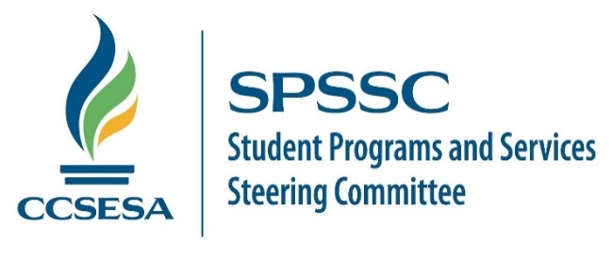

October 28, 2021

Linda Darling-Hammond, President, and Members of the State Board of Education
State Board of Education
1430 N Street
Sacramento, CA 95814
Via email: SBE@cde.ca.gov

Subject: SBE Agenda Item #6: Update to California's Every Student Succeeds Act State Plan: Approval of the Amendments to the State Plan.

Dear President Darling-Hammond and Members of the State Board of Education:

We respectfully submit this letter on behalf of the Student Programs and Services Steering Committee (SPSSC) and the Juvenile Court, Community and Alternative School Administrators of California (JCCASAC) of the California County Superintendents Educational Services Association (CCSESA).

I am the chairperson for the Student Programs and Services Steering Committee (SPSSC). In this role, I represent county-operated student programs, including but not limited to regional special education programs, alternative education programs, juvenile court schools, and independent study programs. County-operated programs serve some of California's most vulnerable PK-12 students in unique educational settings. This letter requests your support with changing California's current Teacher Equity definition under California's Consolidated State Plan under ESSA.

Historically, alternative education programs relied on the understanding (and past reporting practices) that teachers on a Local Assignment Option would be reported under the "with a full credential" category. These teachers provide instruction in a certificated position and are legally authorized to do so by statute.

The teacher quality definitions were updated in November 2019. Due to these updates, the "out of field" definition includes those on local assignment options. Although these teachers meet the CTC and Education Code requirements to be broadly assigned, they will be considered "out-of-field" for ESSA purposes if they do not have a credential for each course they teach.

Changes to the Local Assignment Option will create significant challenges for alternative education settings in which teachers often teach in self-contained settings or teach multiple content areas.

For example, veteran and highly skilled court and community school teachers who teach in a self-contained classroom setting (as most do) will be considered misassigned. Teachers who support notoriously difficult-to-fill county-operated programs may flee to traditional educational settings to avoid being labeled misassigned year after year.

Parents of incarcerated and expelled students (who have no choice in the school's location their child attends) will be notified that the teacher educating their child is misassigned within thirty days of their enrollment. This required notification will cause additional undue stress to parents and guardians with no opportunity for resolution as long as their child remains in a juvenile detention facility or county community school. Parents of students enrolled in these programs have minimal educational options. If parents feel an unqualified teacher is providing instruction, they may choose to remove their child from county-operated programs that provide high-quality academic, behavioral, and social-emotional support.

Many county offices are now required to notify all parents that their child's teacher is considered misassigned. SPSSC and JCCASAC members are deeply concerned the perception will be "low quality" teachers are assigned to teach our students. Stakeholder groups may inappropriately see "misassignment" as evidence that certain student groups receive an inferior education when that isn't at all accurate. As county offices strive to provide high-quality alternative education programs to the state's most vulnerable children, increase rigor and program accountability, this perception negates that effort.

SPPSSC and JCCASAC members recommend the removal of Local Assignment Options from the "out-of-field" teacher definition. The committee is requesting that SBE consider amending the "out-of-field" definition in California's ESSA plan.

Thank you,

Susan Connolly
Assistant Superintendent, Student Services,
Placer County Office of Education
Chair, SPSSC

